1. CSS – blog post

# Fonts

* 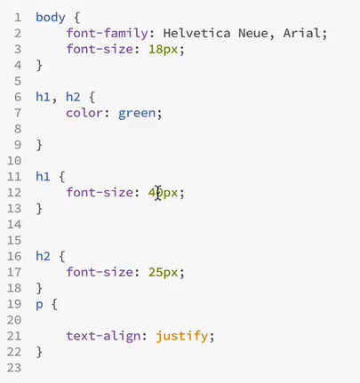

# Box -sizing

* 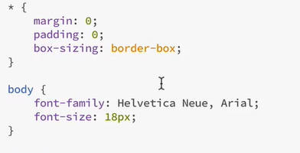

# Margins for h1

* 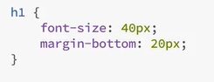

# Margins h2

* 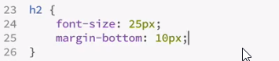

# Margins for p (main-text)

* 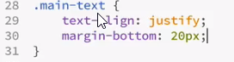

# Simple layout

* 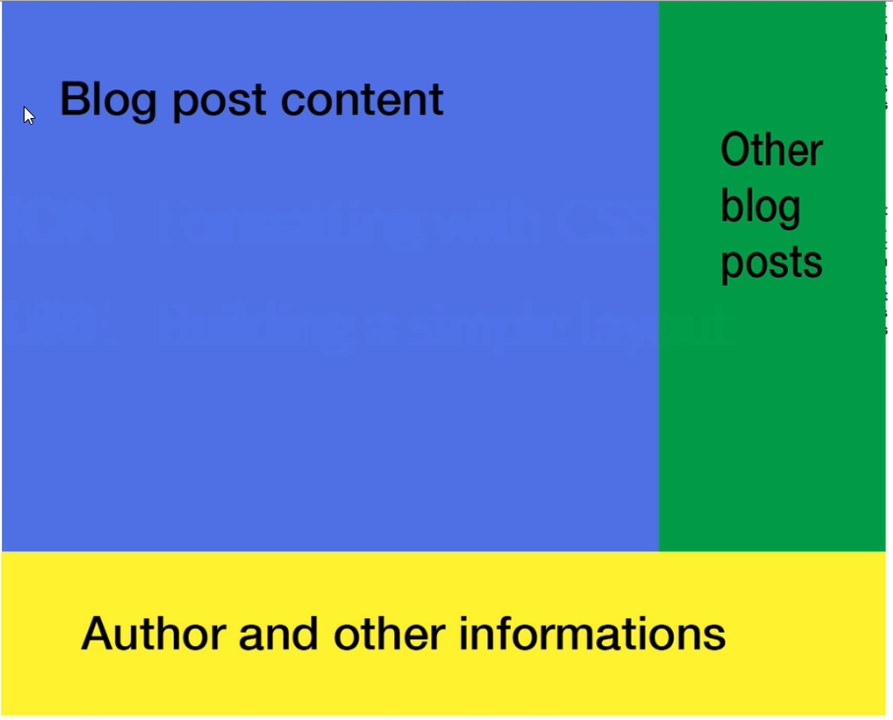

# Top Div class=’container’

* 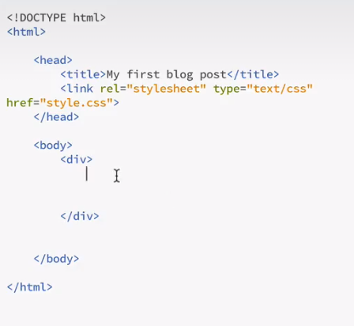

# Styling top div

* 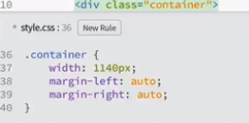

### After this – out blog post is centered!

# Add new div with class=’blog-post’

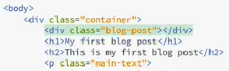

# Style blog post div

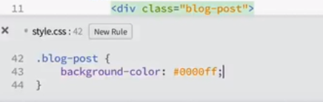

# Add container for other blog posts

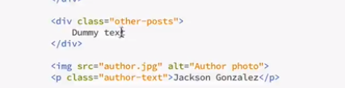

# Style the other blog post

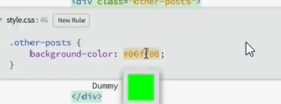

# Add div for author blog

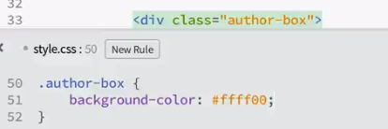

# Check the results

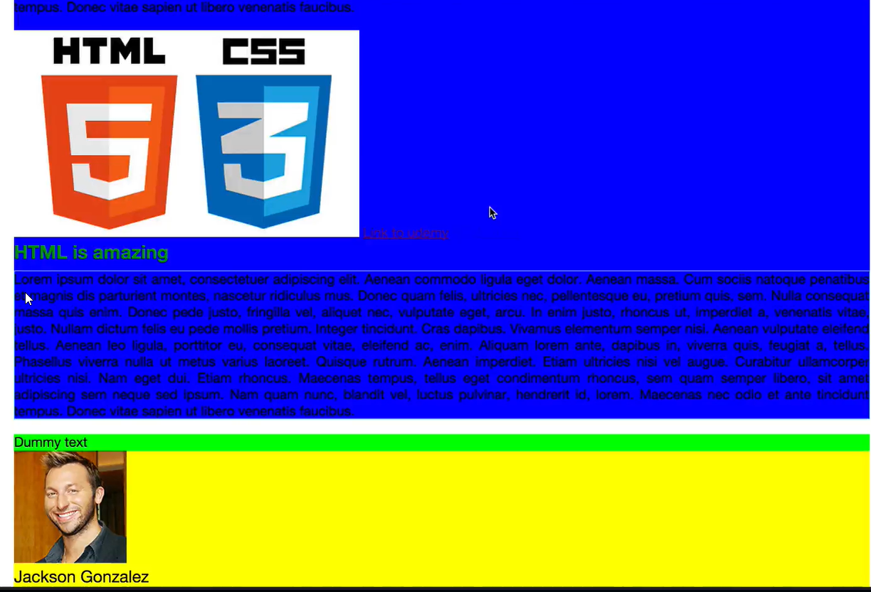

# Put width for blog post and other blog post

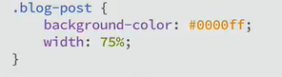

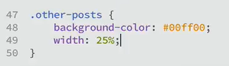

# Put element to float

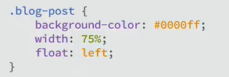

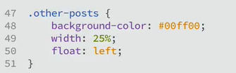

# Problem – author blog post will float also

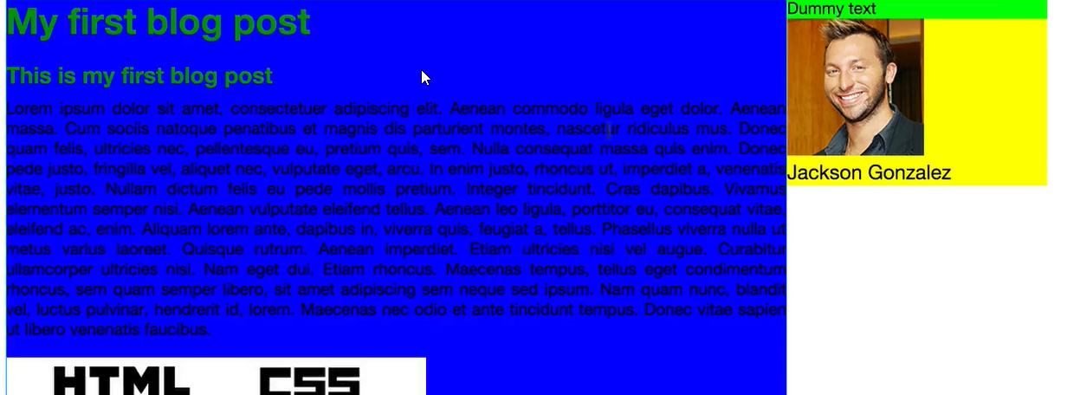

# Solution – add empty box with clear fix class

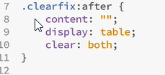

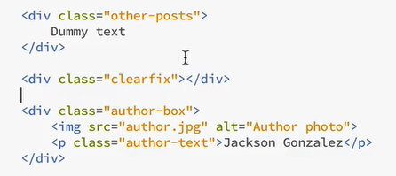

# Add some margins and paddings

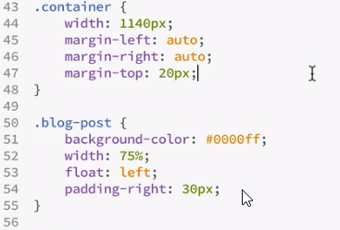

# Remove ugly colors

# Merge margins on container div

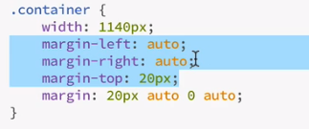

# Add grey line to separate author blog

Border propery omogucava da se postave 3 stvari:

* Border width
* Line type
* Border color

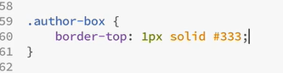

# Add some padding to author

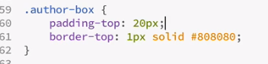

# Polsihing blog post

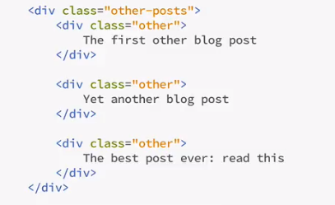

# Add margins

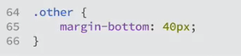

# Select only img in author box



# Make img round

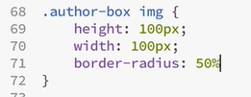

# Put author name next to img (float-left)

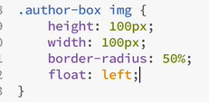 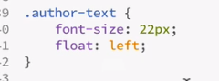

# Margins for author text

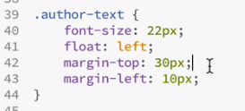

# Move html and css img in the bottom part and make it smaller

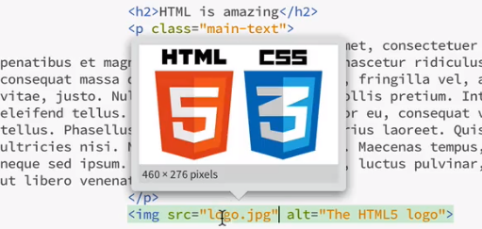 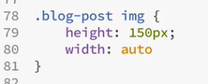

# Last step - put date

